REPORT ON SOCIAL MEDIA POST CLASSIFICATION

A MACHINE LEARNING APPROACH

**A PROJECT REPORT**

***Submitted by***

M. Sasi kumar (23MCI10194)

Rupali (23MCI10137)

***in partial fulfilment for the award of the degree of***

**Master of Computer Applications**

**IN**

Artificial Intelligence And Machine Learning

**Chandigarh University**



OCT 2024



**BONAFIDE CERTIFICATE**

Certified that this project report **“Social Media Post Classification”** is

the bonafide work of **“M.Sasi Kumar , Rupali”**

who carried out the project work under my/our supervision.

**SIGNATURE HEAD OF THE DEPARTMENT**

**SIGNATURE SUPERVISOR**

**INTERNAL EXAMINER EXTERNAL EXAMINER**

**Table Of Content**

**CHAPTER 1. INTRODUCTION .......................................................................4**

1. Introduction to the project

2. Problem Definition and /solution Overview

**Chapter 2: Literature Review/Background Study...........................................................8**

1. Review Summary

2. Goals and Objectives

**CHAPTER 3. SETUP AND DESIGN ..........................................................................**

1. Methodologies and Tools and Technologies

**CHAPTER 4. IMPLEMENTATION AND RESULT............................**

**CHAPTER 5. DEPLOYMENT AND PUBLICATION...................................**

1. Publishing on Github

**CHAPTER 6. FUTURE SCOPE...................................**

**CHAPTER 7. CONCLUSION...................................**

**Chapter – 1: INTRODUCTION**

1. Introduction to the Project

In the digital age, social media has become a major source of information, entertainment, and communication, influencing millions of users worldwide. With platforms like Facebook, Twitter, Instagram, and LinkedIn generating enormous volumes of user-generated content every day, it has become increasingly important for these platforms—and for businesses, researchers, and governments—to understand, categorize, and make sense of this data. Social media post classification is a technique that aims to address this need by automatically categorizing posts based on content, sentiment, topic, or user intent.

**Purpose and Scope of Classification**

The purpose of social media post classification is to provide a structured approach to handling unstructured text data, allowing for better insights into trends, behaviors, and public sentiment. By classifying posts, organizations can automate processes such as content recommendation, advertisement targeting, and even regulatory compliance. For instance, posts can be categorized by topic (e.g., sports, politics, entertainment), sentiment (positive, negative, neutral), or purpose (informational, promotional, personal), all of which can provide platforms and brands with actionable insights.

**Applications and Benefits**

1. **Enhanced User Experience**: Classification helps personalize the content shown to each user, tailoring it to their interests and preferences. This is key to user retention and engagement on social media platforms.
2. **Content Moderation**: By categorizing posts according to their content and context, platforms can identify and address potentially harmful or offensive material, contributing to safer online spaces. Classification tools also help in filtering out spam or bot-generated content, maintaining a higher quality of user interaction.
3. **Market and Trend Analysis**: For businesses, understanding what users are talking about, their preferences, and the sentiment behind these conversations is essential. Classification helps in identifying and monitoring trends in real-time, allowing businesses to adapt to changing market demands, predict emerging trends, and refine their strategies accordingly.
4. **Automated Decision Making**: Machine learning models can be trained to make real-time decisions, such as flagging inappropriate content, suggesting responses, or prioritizing customer inquiries, based on the classification of social media posts.

**Challenges and Opportunities**

While social media post classification holds great potential, it also faces certain challenges. The informal nature of social media content—filled with slang, abbreviations, and varying linguistic styles—can make accurate classification difficult. Additionally, evolving topics and sentiments can require constant updates to classification models. However, advancements in natural language processing (NLP), machine learning, and artificial intelligence offer promising solutions, improving the accuracy and adaptability of classification models.

In sum, social media post classification is a powerful tool in the era of big data. By converting vast and diverse user-generated content into structured insights, it enables platforms, businesses, and researchers to better understand and respond to their audiences, contributing to more personalized, safe, and effective digital experiences.

Social media classification plays a crucial role in today’s digital landscape, where vast amounts of data are generated every second across various platforms. As social media platforms continue to grow, so does the need to analyze and categorize content effectively. Here’s how classification contributes to user insights, content moderation, and trend analysis:

**1. User Insights**

* **Personalized Content**: By classifying social media posts, platforms can understand individual user interests and preferences. This enables the delivery of personalized content, which enhances user experience and increases engagement.
* **Behavior Analysis**: Classification allows businesses and researchers to study patterns in user behavior. For example, knowing the types of posts a user engages with can provide insights into their interests, which can be valuable for targeted marketing and product recommendations.
* **Audience Segmentation**: By categorizing posts and users based on interests, platforms can segment their audience into specific groups, such as fitness enthusiasts or tech-savvy individuals. This enables advertisers to target relevant audiences more effectively.

**2. Content Moderation**

* **Safety and Policy Enforcement**: Social media classification helps platforms automatically flag or block inappropriate, harmful, or offensive content. Algorithms can classify posts based on their adherence to community guidelines, helping prevent the spread of misinformation, hate speech, and other undesirable content.
* **Efficient Moderation**: Given the sheer volume of content posted daily, manual moderation is impractical. Automated classification streamlines the moderation process, ensuring that harmful or inappropriate content is quickly identified and addressed.
* **User Trust**: Effective content moderation through classification contributes to a safer online environment. When users trust that harmful or inappropriate content is handled responsibly, it can enhance platform credibility and attract more users.

**3. Trend Analysis**

* **Identifying Emerging Trends**: Classification helps detect patterns across a large volume of posts, allowing platforms and businesses to recognize trending topics or emerging interests. For instance, a sudden spike in discussions around a particular hashtag or product can be quickly identified and responded to.
* **Understanding Sentiment and Public Opinion**: By categorizing posts and analyzing sentiment, companies can gauge public opinion on various topics. This is particularly valuable in fields like brand management, where understanding customer sentiment around a product or service can guide marketing strategies.
* **Competitive Analysis**: Social media classification enables businesses to analyze content strategies of competitors by examining the types of posts they share and how their audience responds. This insight can inform a company’s own social media strategy, allowing them to stay competitive.

1. Problem Definition and Solution Overview:

**Problem Definition**

The problem of social media post classification involves the automatic categorization of user-generated posts on social media platforms. Given the vast amount of content generated every second, it is challenging for platforms and organizations to manually sift through posts to understand topics, trends, user sentiments, or the relevance of the content. Without an automated classification system, managing and making sense of this data becomes unfeasible, resulting in missed insights, reduced user engagement, and potential lapses in content moderation.

Social media posts often contain unstructured text, a mix of images or multimedia, and sometimes even informal language, emojis, or hashtags, which complicates traditional data processing approaches. Therefore, the primary challenges are:

1. Accurately identifying and categorizing posts based on topic, sentiment, or intent.
2. Handling high volumes of text data in real-time, enabling timely responses.
3. Ensuring the system adapts to constantly evolving language, slang, and trends on social media.

**Solution Overview**

To address the problem, machine learning techniques, specifically Random Forest classification, offer a robust solution for classifying social media posts. Random Forest, an ensemble learning method, combines multiple decision trees to make accurate predictions and handle noisy data effectively.

**Solution Using Random Forest Classification**

Random Forest classification works well for social media post classification because of its adaptability and high performance with complex data. The solution generally involves the following steps:

1. **Data Preprocessing**: The data is cleaned and preprocessed, including handling missing values, encoding categorical variables, and scaling numerical features. Label encoding is often used for categorical features like post categories or social media platforms.
2. **Feature Selection and Engineering**: Textual features can be extracted and transformed using methods like bag-of-words, TF-IDF, or embeddings, and combined with metadata features (e.g., post time, user demographics). Random Forest’s ability to rank feature importance also aids in selecting the most significant predictors.
3. **Training the Random Forest Model**: The Random Forest classifier is trained on the preprocessed data. By constructing numerous decision trees and averaging their predictions, the model reduces overfitting and improves accuracy on unseen data. During training, the model learns to distinguish between different post categories, such as identifying trending topics, flagging inappropriate content, or segmenting posts by user interest.
4. **Hyperparameter Optimization**: Hyperparameters like the number of trees, maximum depth, and minimum samples per split are optimized to maximize the model’s accuracy and robustness.
5. **Model Evaluation and Testing**: The trained model is evaluated on a test dataset to measure its performance, with metrics such as accuracy, precision, recall, and F1-score. This ensures that the classifier can generalize to new data and accurately categorize posts.
6. **Implementation and Deployment**: Once the model is fine-tuned and tested, it can be deployed to classify social media posts in real-time, providing platforms with insights on user behavior, trends, and sentiment.

Random Forest classification offers a solution that is both accurate and efficient, enabling the automated and scalable classification of social media posts. This approach ultimately improves content personalization, enhances content moderation, and provides businesses and platforms with actionable insights from user-generated content.

**Problem Definition: Social Media Post Classification**

Social media platforms generate massive volumes of diverse and unstructured user content daily. Posts often contain a mixture of text, images, videos, and other multimedia, along with slang, emojis, hashtags, and varied linguistic styles. Manually sorting and analyzing this content is nearly impossible due to its sheer volume and complexity, but without a method for automated categorization, social media platforms and businesses miss out on crucial insights and opportunities.

The problem of social media post classification can be defined as follows:

1. **Understanding User Intent**: Social media posts reflect user intent—such as sharing news, expressing opinions, asking questions, or promoting products. Accurately classifying posts by intent helps platforms serve relevant content to users and advertisers deliver targeted ads.
2. **Managing Content Moderation**: With a high volume of posts, ensuring the removal of inappropriate, harmful, or spam content becomes challenging without an automated system. Missteps in moderation can lead to negative user experiences, impacting trust and platform reputation.
3. **Gaining Market and Trend Insights**: Businesses rely on social media to understand public opinion, identify trends, and gauge customer sentiment. Without accurate classification, detecting shifts in trends and sentiment across large datasets is difficult, limiting businesses’ ability to make timely, data-driven decisions.
4. **Personalizing Content for User Engagement**: By classifying posts into categories that match users’ preferences, platforms can enhance engagement through tailored content recommendations. However, without an automated classification system, personalizing content at scale is impractical.

**Solution Using Machine Learning and Random Forest Classification**

The solution to social media post classification leverages machine learning, specifically Random Forest classification, to automatically categorize posts based on their content and context. Random Forest is an ensemble learning method that builds multiple decision trees and aggregates their predictions for improved accuracy and generalizability. This approach is especially effective for high-dimensional data, handling noise well, and reducing the risk of overfitting.

**Key Steps in the Solution:**

1. **Data Preprocessing**: The raw social media data is first cleaned and preprocessed. This includes handling missing values, encoding categorical features (like hashtags or categories), and normalizing numerical features. Text features are transformed using methods like TF-IDF or word embeddings to capture the semantic meaning of each post.
2. **Feature Selection and Engineering**: Additional features, such as metadata (time of post, user demographics), are combined with text-based features to enhance classification accuracy. The Random Forest model also identifies important features, aiding in feature selection.
3. **Training the Random Forest Model**: The Random Forest classifier is trained on labeled social media posts. Each decision tree within the model is trained on a subset of the data, capturing patterns in post content and making it possible to distinguish categories like trending topics, user sentiment, or intent.
4. **Hyperparameter Tuning**: Random Forest’s hyperparameters, such as the number of trees, tree depth, and sample splits, are optimized to improve accuracy and efficiency. This ensures the model performs well on unseen data and is less likely to overfit.
5. **Model Evaluation**: The trained model is evaluated using accuracy, precision, recall, and F1-score, ensuring reliable classification performance on new, real-world social media posts.
6. **Deployment**: Once fine-tuned, the model is deployed to categorize social media posts in real-time, providing insights into user behavior, detecting trends, and flagging inappropriate content.

Using Random Forest classification allows for an adaptable, high-performing solution capable of handling the variability in social media posts, automating the categorization process, and generating actionable insights at scale.

**Chapter 2: Literature Review/Background Study**

**Review Summary**

Social media post classification is a widely researched topic, as platforms aim to make sense of user-generated content through automated categorization. Various studies have explored diverse methodologies, from traditional text analysis to more advanced machine learning and deep learning techniques. Key themes in these studies include the processing of unstructured data, sentiment and intent analysis, and the implementation of classification algorithms optimized for text data.

**Text Analysis and Natural Language Processing (NLP)**:

Text analysis has long been fundamental to social media data classification, with Natural Language Processing (NLP) techniques providing a foundation for understanding language structure, sentiment, and meaning within posts. Studies on NLP for social media focus on transforming unstructured text into structured formats that algorithms can process.

Common NLP techniques include tokenization (breaking down text into words or phrases), stop-word removal, stemming, lemmatization, and n-grams. These methods aid in reducing text complexity, handling noise, and ensuring that only meaningful data are processed.

Sentiment analysis and topic modeling are also integral to NLP studies, helping to understand user sentiment (positive, neutral, negative) and to group posts based on topic, enabling deeper insights into user opinions and trends.

**Machine Learning Classification Techniques**:

* + Various machine learning algorithms have been used for social media classification, each with unique strengths and limitations. Some popular classifiers include:
    - **Support Vector Machines (SVM)**: Known for its high performance on text classification tasks, SVMs find an optimal hyperplane to categorize posts. SVM performs well with small, high-dimensional data but may struggle with very large datasets typical in social media.
    - **Naïve Bayes**: Often used in text classification due to its simplicity and speed, Naïve Bayes models assume independence among features, which can be effective in some cases but may not always capture the complexity of social media data.
    - **Decision Trees and Ensemble Methods**: Decision trees are interpretable and can handle mixed data types, but ensemble methods like Random Forest and Gradient Boosting are more robust. These methods aggregate predictions from multiple trees, reducing overfitting and increasing accuracy.
    - **Deep Learning Models**: More recent studies leverage deep learning models such as Recurrent Neural Networks (RNNs) and Transformers (like BERT) for social media text classification. These models excel in capturing contextual nuances but often require substantial computational resources.

1. **Random Forest and Its Application to Social Media Data**:
   * Random Forest, an ensemble method, combines multiple decision trees to make a final prediction. Each tree is trained on a subset of data, allowing the model to learn from different patterns. Studies show that Random Forest performs well with noisy, unstructured data and is less prone to overfitting than single-decision models.
   * Random Forest is especially useful for high-dimensional data with many features, as it can rank feature importance, providing insights into which factors (e.g., keywords, hashtags) are most predictive of post categories. Researchers have highlighted Random Forest’s adaptability to varied datasets, making it suitable for social media classification where text, metadata, and user demographics often intersect.
2. **Challenges and Advancements**:
   * A major challenge in social media classification is the diversity and informality of language, with slang, abbreviations, and emojis frequently used. Studies indicate that NLP advancements like word embeddings (e.g., Word2Vec, GloVe) and contextual models (e.g., BERT) have improved classification accuracy by capturing language nuances.
   * Class-imbalance issues, where certain categories are more prevalent, are common in social media data. Techniques like oversampling, undersampling, and cost-sensitive learning have been explored to address this imbalance, enhancing the model’s accuracy across categories.
   * Furthermore, real-time classification is an area of active research. Given the dynamic nature of social media, studies are investigating low-latency models and streaming data solutions that enable platforms to classify posts instantly.

**Goals and Objectives**

The objectives of social media post classification using Random Forest aim to balance high accuracy, scalability, and interpretability, addressing the unique demands of social media data.

1. **Achieve High Classification Accuracy**: The primary goal is to build a reliable model that accurately categorizes social media posts across various classes, ensuring that the classification system is robust and suitable for deployment.
2. **Segment Content by Platform and Category**: By classifying content from multiple platforms (e.g., Twitter, Instagram, Facebook), the model will provide insights into platform-specific trends, enabling marketers and platform operators to tailor strategies and recommendations accordingly. Additionally, categorizing posts by topic (e.g., entertainment, news, personal) allows for more personalized user experiences.
3. **Enable Real-Time or Near Real-Time Classification**: To be effective, the classification system should handle new posts as they are generated. The goal is to achieve a model that supports real-time or near-real-time categorization without compromising on accuracy.
4. **Support Content Moderation and Sentiment Analysis**: Beyond categorization, the model should assist in filtering or flagging inappropriate content to enhance moderation efforts. Additionally, sentiment analysis can help classify posts by user sentiment, enabling a deeper understanding of public opinion and user feedback.
5. **Adaptability and Scalability**: The solution should be scalable to handle high volumes of data and adaptable to changes in social media language, such as the emergence of new slang or hashtags.
6. **Provide Interpretability through Feature Importance**: Random Forest’s ability to rank feature importance will help stakeholders understand which features are most influential in post classification, adding a layer of interpretability to the model that is essential for business use and trust.

By meeting these objectives, the classification system will enable platforms and businesses to harness insights from social media data efficiently, providing a comprehensive understanding of trends, user sentiments, and topics in real-time.

**Summary of Relevant Studies and Existing Methods for Social Media Data Classification**

The classification of social media data has garnered significant attention in recent years, given the explosive growth of user-generated content across various platforms. Researchers and practitioners have explored a variety of methods to effectively categorize this unstructured data, leveraging techniques from natural language processing (NLP) to machine learning. Here is a summary of key studies and existing methodologies in this domain:

1. **Text Analysis and Natural Language Processing (NLP)**:
   * **NLP Techniques**: Fundamental to social media classification, NLP techniques such as tokenization, stemming, lemmatization, and stop-word removal are commonly employed. For instance, Liu et al. (2018) demonstrated that preprocessing steps significantly improve classification accuracy by removing noise and irrelevant content.
   * **Sentiment Analysis**: Studies have focused on sentiment analysis to gauge user opinions. For example, Bifet and Frank (2010) applied sentiment analysis on Twitter data, utilizing lexicon-based and machine learning approaches to classify tweets as positive, negative, or neutral.
   * **Topic Modeling**: Techniques like Latent Dirichlet Allocation (LDA) have been used to identify topics within social media posts. A study by Bleiholder et al. (2019) explored topic modeling to group posts based on shared themes, aiding in the understanding of user interests and trends.
2. **Machine Learning Classifiers**:
   * **Support Vector Machines (SVM)**: SVMs have been popular in text classification tasks due to their ability to handle high-dimensional spaces. Research by Joachims (1998) highlighted SVM's effectiveness in categorizing documents, leading to its adoption for social media data classification.
   * **Naïve Bayes Classifier**: Known for its simplicity, the Naïve Bayes classifier is often used for text categorization. Studies, such as those by Zhang (2004), indicate that despite its independence assumption, Naïve Bayes performs surprisingly well in practice, especially for spam detection on social media platforms.
   * **Decision Trees and Random Forests**: Decision trees are intuitive and interpretable, making them useful for social media classification. Random Forest, an ensemble method, combines multiple decision trees and has been shown to improve accuracy and reduce overfitting. Research by Liaw and Wiener (2002) illustrated Random Forest's robustness in handling diverse datasets.
3. **Deep Learning Approaches**:
   * **Recurrent Neural Networks (RNNs)**: RNNs and their variants, such as Long Short-Term Memory (LSTM) networks, are designed to capture sequential dependencies in text data. A study by Zhang et al. (2015) showcased the use of LSTMs for sentiment classification in tweets, achieving superior performance compared to traditional methods.
   * **Transformer Models**: More recently, transformer-based models like BERT (Bidirectional Encoder Representations from Transformers) have gained popularity due to their ability to understand context and nuances in language. Research by Devlin et al. (2018) demonstrated that BERT outperforms prior state-of-the-art models on various NLP tasks, including social media classification.
4. **Hybrid Approaches**:
   * Several studies have adopted hybrid methods that combine traditional machine learning techniques with deep learning. For instance, a study by Khadidi et al. (2020) combined feature extraction from text data using BERT with a Random Forest classifier to improve classification accuracy in identifying fake news on social media.
5. **Challenges in Social Media Classification**:
   * **Language Diversity**: The informal nature of social media language, including slang, abbreviations, and emojis, poses challenges for classification. Studies indicate that traditional NLP techniques often struggle with such variability, necessitating the development of more sophisticated models.
   * **Class Imbalance**: Social media datasets often suffer from class imbalance, where certain categories are underrepresented. Research has explored techniques such as oversampling, undersampling, and cost-sensitive learning to address this issue, as highlighted in studies by He and Garcia (2009).
6. **Real-Time Classification**:
   * The need for real-time classification systems has led to advancements in low-latency models capable of processing streams of social media data. Research by Li et al. (2018) demonstrated methods for efficiently classifying tweets in real time, crucial for applications such as crisis management and trend analysis.

**Conclusion**

The landscape of social media data classification is evolving rapidly, with a blend of traditional and contemporary techniques being explored to enhance accuracy and interpretability. The use of NLP, machine learning classifiers, and deep learning approaches has advanced the field, enabling better handling of unstructured data while addressing challenges related to language diversity and class imbalance. Future research will likely focus on refining these methods and developing more robust systems capable of real-time analysis and contextual understanding.

**Methods for Social Media Post Classification**

The classification of social media posts involves several methodologies, each employing unique techniques and algorithms to analyze and categorize the vast amounts of unstructured data generated on various platforms. Here’s a detailed discussion of key methods, including text analysis, natural language processing (NLP), and various machine learning classifiers:

**1. Text Analysis**

Text analysis is the foundational method for processing and extracting meaningful information from textual data. This includes several techniques:

* **Tokenization**: The process of breaking down text into individual words or tokens. Tokenization is essential as it prepares the text for further analysis, allowing algorithms to work with discrete units of meaning.
* **Stemming and Lemmatization**: These techniques reduce words to their base or root forms. Stemming removes suffixes, while lemmatization considers the context and converts words to their dictionary form. For instance, "running" becomes "run". This helps standardize terms, reducing dimensionality and improving classification accuracy.
* **Stop-word Removal**: Common words like "and," "the," and "is" that carry little meaning are removed from the text. This simplification helps focus on the more significant terms that contribute to the meaning of the content.
* **N-grams**: This technique involves the extraction of contiguous sequences of n items (words or characters) from the text. Bigrams (two-word sequences) and trigrams (three-word sequences) capture phrases that can provide additional context, aiding classification tasks.

**2. Natural Language Processing (NLP)**

NLP encompasses a range of computational techniques that enable machines to understand, interpret, and generate human language. Key NLP techniques relevant to social media classification include:

* **Sentiment Analysis**: This technique evaluates the emotional tone behind a body of text, classifying it as positive, negative, or neutral. It is particularly useful for understanding user opinions and sentiments about brands, products, or current events. Tools like VADER (Valence Aware Dictionary and sEntiment Reasoner) and machine learning-based approaches are commonly used for this purpose.
* **Named Entity Recognition (NER)**: NER identifies and categorizes key entities in text, such as names of people, organizations, and locations. This helps in classifying posts based on specific topics or themes relevant to current discussions.
* **Part-of-Speech (POS) Tagging**: This process involves labeling words with their corresponding parts of speech, which helps in understanding the grammatical structure of the text. POS tagging can provide insights into the context and enhance the classification by focusing on specific types of words (e.g., nouns, verbs).
* **Topic Modeling**: Techniques like Latent Dirichlet Allocation (LDA) identify the underlying topics within a collection of posts. Topic modeling helps classify content based on prevalent themes, enabling the grouping of posts that share similar subjects.

**3. Machine Learning Classifiers**

Machine learning classifiers are algorithms that learn from labeled training data to make predictions about unseen data. Various classifiers have been employed for social media post classification, including:

* **Naïve Bayes Classifier**: This probabilistic classifier applies Bayes’ theorem, assuming independence among features. It is particularly effective for text classification tasks due to its simplicity and efficiency. Research indicates that Naïve Bayes works well for spam detection and sentiment analysis in social media contexts.
* **Support Vector Machines (SVM)**: SVMs are effective for high-dimensional data and work by finding the hyperplane that best separates different classes. SVMs are commonly used in text classification due to their robustness in handling sparse data and their ability to generalize well.
* **Decision Trees**: These models use a tree-like structure to make decisions based on feature values. Decision trees are intuitive and interpretable, making them suitable for understanding how classification decisions are made. They can be prone to overfitting, but techniques like pruning help mitigate this issue.
* **Random Forest**: An ensemble method that combines multiple decision trees to improve classification accuracy. Random Forest reduces the risk of overfitting associated with individual decision trees and is known for its robustness. It is effective in handling large datasets with many features.
* **K-Nearest Neighbors (KNN)**: A non-parametric method that classifies data points based on the majority class among their nearest neighbors. KNN is simple to implement but can be computationally expensive, especially with large datasets.
* **Deep Learning Models**: Recently, deep learning approaches such as Convolutional Neural Networks (CNNs) and Recurrent Neural Networks (RNNs) have been applied to text classification. CNNs can capture spatial hierarchies in data, while RNNs are effective in understanding sequential relationships in text. Models like BERT (Bidirectional Encoder Representations from Transformers) have revolutionized NLP tasks, achieving state-of-the-art results in various classification challenges.

**4. Hybrid Approaches**

Combining different methods often yields better results. For example, a hybrid model might use traditional text preprocessing techniques alongside deep learning models to enhance classification accuracy. Additionally, stacking classifiers—where multiple models are trained and their predictions are combined—can improve performance on complex datasets.

**Conclusion**

The combination of text analysis, NLP, and various machine learning classifiers provides a robust framework for social media post classification. By leveraging these methods, organizations can effectively analyze user-generated content, enabling insights into trends, user sentiments, and more, thereby enhancing their ability to engage with users and tailor content accordingly. As the digital landscape evolves, ongoing advancements in these methodologies will continue to refine classification capabilities and address emerging challenges in social media analytics.

* 1. Goals and Objectives

**Goals and Objectives for Social Media Post Classification**

When undertaking a project focused on social media post classification, it is essential to outline clear and specific goals and objectives to guide the development and evaluation of the classification model. The following objectives are designed to enhance the effectiveness and applicability of the classification system:

**1. Achieving High Classification Accuracy**

* **Objective**: Develop a machine learning model capable of achieving a classification accuracy of at least 90%.
* **Rationale**: High accuracy is critical for ensuring the reliability of insights derived from classified posts, which can inform marketing strategies, content creation, and user engagement efforts.

**2. Segmenting Content by Social Media Platform**

* **Objective**: Classify posts based on the specific social media platform used (e.g., Facebook, Twitter, Instagram).
* **Rationale**: Different platforms have unique user bases and content styles. By segmenting content, organizations can tailor their strategies to meet the preferences of users on each platform, maximizing engagement and effectiveness.

**3. Categorizing Content by Topic and Type**

* **Objective**: Implement classification that identifies and categorizes posts into specific topics (e.g., sports, politics, entertainment) and types (e.g., news, opinion, advertisement).
* **Rationale**: This categorization allows for better content targeting and enables businesses to understand trending topics within their audience, leading to more effective communication strategies.

**4. Analyzing Sentiment and User Engagement**

* **Objective**: Incorporate sentiment analysis into the classification process to evaluate user sentiments toward posts (positive, negative, neutral).
* **Rationale**: Understanding user sentiment helps organizations gauge public opinion and tailor responses or strategies accordingly, enhancing user engagement and satisfaction.

**5. Identifying Key Influencers and Trends**

* **Objective**: Utilize classification results to identify influential users and emerging trends in social media discussions.
* **Rationale**: Identifying influencers can inform marketing and partnership strategies, while trend analysis helps businesses stay ahead of market shifts and audience interests.

**6. Enhancing Model Interpretability**

* **Objective**: Ensure that the classification model is interpretable, allowing stakeholders to understand how classifications are made and the features that contribute to decisions.
* **Rationale**: Interpretability builds trust in the model's predictions and enables stakeholders to make informed decisions based on the model's insights.

**7. Continuous Improvement and Model Adaptability**

* **Objective**: Establish a framework for continuous model evaluation and retraining to adapt to changing social media dynamics and user behavior.
* **Rationale**: Social media is an ever-evolving landscape; a model that can adapt to new trends, language use, and user interactions will remain relevant and effective over time.

**8. Scalability and Deployment**

* **Objective**: Design the classification system to be scalable and capable of handling large volumes of social media data in real-time.
* **Rationale**: Scalability is crucial for organizations looking to analyze social media at scale, enabling timely insights that can inform immediate actions or responses.

**Conclusion**

These goals and objectives provide a comprehensive framework for developing an effective social media post classification system. By focusing on accuracy, segmentation, sentiment analysis, and continuous improvement, organizations can leverage classification to enhance their engagement with users, understand trends, and make data-driven decision

**Chapter 3: Setup and Design**

**Methodologies and Tools/Technologies**

This project implements various preprocessing, encoding, and visualization tools to ensure accurate and interpretable classification. The key methodologies and tools/technologies utilized include:

1. **Data Preprocessing**
   * **Missing Value Handling**: Data preprocessing involves filling missing values, which are common in social media data due to incomplete user profiles or optional fields.
     + **Approach**: For categorical data, missing values are filled with the mode (most frequent value). For numerical data, the median is used to fill in missing values, as it is less affected by outliers.
   * **Objective**: Ensure a clean dataset where missing values do not compromise model accuracy and overall data quality.
2. **Feature Encoding**
   * **LabelEncoder**: Used for converting categorical data into a numerical format.
     + **Approach**: Each unique category in a column is assigned a numeric label, allowing categorical data to be used as features in machine learning models.
     + **Application**: Applied to columns like "Which Social Media Platform do you use the Most?" and other non-numeric columns to transform them into a format that can be used by machine learning algorithms.
   * **StandardScaler**: Used for scaling numerical features to standardize the data.
     + **Approach**: StandardScaler scales the dataset by removing the mean and scaling it to unit variance, which is essential for machine learning algorithms sensitive to the scale of data.
     + **Application**: Applied to features like age and other numeric values to ensure consistency in model training and avoid feature dominance due to scale differences.
3. **Data Manipulation**
   * **Pandas**: Utilized for data loading, cleaning, and manipulation.
     + **Functionality**: Allows for seamless reading of CSV files, handling missing values, and performing transformations on the data.
     + **Objective**: Enable efficient data handling and manipulation to prepare the data for machine learning.
4. **Machine Learning**
   * **Scikit-learn**: Core library for implementing machine learning algorithms and utilities.
     + **Functionality**: Used for training the Random Forest classifier, splitting data into training and testing sets, evaluating model performance, and performing hyperparameter tuning.
     + **Objective**: Scikit-learn provides a reliable and well-optimized toolkit for classification tasks, allowing for easy experimentation with various models and configurations.
5. **Data Visualization**
   * **Seaborn and Matplotlib**: Libraries for creating detailed and interpretative visualizations.
     + **Functionality**: Used for plotting distributions, feature importance, confusion matrices, and other graphs to understand data patterns and classification outcomes.
     + **Objective**: Facilitate the analysis and interpretation of data trends and model performance, making it easier to communicate results and findings.

**Hardware and Software Specifications**

1. **Hardware Setup**
   * **Environment**: Google Colab
     + **Justification**: Colab provides free access to GPU and TPU resources, making it ideal for data-heavy machine learning projects. The cloud-based environment also enables seamless collaboration and consistent environment configurations.
   * **Alternative Setup**: Local machine with an Intel i5 processor or higher, 8GB of RAM, and at least 20GB of storage for data handling and processing.
2. **Software Specifications**
   * **Python Version**: Python 3.8 or higher, used for compatibility with the latest versions of libraries.
   * **Libraries**:
     + **Pandas (v1.3.3)**: For data manipulation and analysis.
     + **NumPy (v1.21.2)**: For numerical operations, essential in array manipulations used in machine learning.
     + **Scikit-learn (v0.24.2)**: For machine learning model training, evaluation, and preprocessing utilities.
     + **Matplotlib (v3.4.3)** and **Seaborn (v0.11.2)**: For data visualization, enabling plot generation for understanding data distributions and model results.
   * **Additional Cloud-Based Tools**:
     + **Google Colab**: As a development environment, it provides necessary dependencies pre-installed and offers GPU/TPU for accelerated training.
     + **Data Source**: Data file (1000_students_data.csv) stored on Colab’s local environment for quick access and reproducibility.

These methodologies and specifications ensure an efficient workflow for preprocessing, training, and analyzing results, while providing a flexible setup that can be reproduced on various platforms. The use of LabelEncoder and StandardScaler optimizes data preparation for machine learning, and libraries like Pandas and Seaborn streamline data manipulation and visualization. Through these tools, the project achieves high-quality, interpretable results in social media post classification.

The preprocessing and feature encoding approach is essential for transforming raw social media data into a format that can be effectively used by machine learning algorithms. Here’s a breakdown of the steps and tools used, specifically focusing on **LabelEncoder** and **StandardScaler**:

**Preprocessing Approach**

Social media data often includes categorical values (e.g., platform names) and may have missing data. Preprocessing addresses these issues to ensure a clean and consistent dataset:

1. **Handling Missing Values**:
   * **Categorical Data**: Missing values in categorical columns are replaced with the **mode** (most frequent value) of that column. This method maintains the distribution of categories, which is crucial for preserving trends in the dataset.
   * **Numerical Data**: For numerical columns, missing values are filled with the **median** of that column. The median is chosen as it is less influenced by extreme values, or outliers, than the mean, ensuring a more stable dataset.

**Feature Encoding with LabelEncoder**

Since many machine learning models require numeric inputs, categorical text data must be converted into numbers. **LabelEncoder** is used to transform these categorical features into a numeric format:

* **How LabelEncoder Works**: LabelEncoder assigns a unique integer to each category in a column. For example, if the column “Which Social Media Platform do you use the Most?” contains values like "Facebook," "Instagram," and "Twitter," LabelEncoder maps these categories to integers, such as 0, 1, and 2, respectively.
* **Why LabelEncoder is Used**: This approach ensures that categorical variables are effectively represented as numeric data, without implying any ordinal relationship between the categories. It allows the model to process these variables effectively while preserving their categorical nature.

**Scaling with StandardScaler**

Standardization is an essential step to ensure that numeric features have a consistent scale. **StandardScaler** is used to scale numeric features, making them suitable for use in the model:

* **How StandardScaler Works**: StandardScaler standardizes features by removing the mean and scaling to unit variance. Each feature is centered around zero with a standard deviation of one, creating a consistent range across all numeric features.
* **Why StandardScaler is Used**: Many machine learning algorithms, such as Random Forest, are sensitive to the range of data values. Scaling prevents any one feature from disproportionately influencing the model simply due to its range, leading to more balanced model training and improved performance.

**Summary**

This preprocessing and encoding approach ensures that the dataset is ready for effective and accurate classification by the machine learning algorithm. By handling missing values, encoding categorical data with LabelEncoder, and standardizing numerical data with StandardScaler, we create a clean, consistent dataset that allows the model to focus on the underlying patterns in social media posts.

In this project, we utilize three powerful libraries—**pandas**, **scikit-learn**, and **seaborn**—each serving a distinct purpose in social media post classification:

**1. Pandas for Data Manipulation**

* **Overview**: Pandas is a widely used Python library for data manipulation and analysis. It provides flexible data structures like DataFrames, which allow for efficient data cleaning, manipulation, and transformation.
* **Usage**: We use pandas to load, inspect, clean, and preprocess the social media data. This includes handling missing values, exploring data distributions, and managing categorical variables. Pandas makes it easy to filter and organize the data for further analysis.

**2. Scikit-Learn for Machine Learning**

* **Overview**: Scikit-learn is a versatile machine learning library in Python that provides a broad range of tools for supervised and unsupervised learning, model selection, preprocessing, and evaluation.
* **Usage**: Scikit-learn is used to implement the Random Forest classifier, which is employed for classifying social media posts. The library’s LabelEncoder and StandardScaler functions are used for preprocessing data, while train_test_split helps in dividing the dataset into training and test sets. We also use RandomizedSearchCV from scikit-learn for hyperparameter tuning to optimize the model’s performance.

**3. Seaborn for Visualization**

* **Overview**: Seaborn is a statistical data visualization library in Python, built on top of matplotlib. It is especially well-suited for creating informative and attractive statistical graphics.
* **Usage**: In this project, seaborn is used to create visualizations that help interpret the data and model results. For example, bar plots display the distribution of social media platform usage and post categories, and a heatmap illustrates the confusion matrix, making it easier to see the model’s performance across different categories.

Together, pandas, scikit-learn, and seaborn provide a complete toolkit for data manipulation, machine learning, and visualization, allowing us to develop and evaluate a robust model for social media post classification.

**Hardware Setup for Social Media Post Classification Project**

This project was conducted on **Google Colab**, a cloud-based platform that provides free access to computational resources. Additionally, it can also be run on a local machine with specific hardware specifications. Below is a description of both setups:

**1. Google Colab Setup**

**Google Colab** provides access to virtualized hardware with the following features:

* **CPU**: Typically Intel® Xeon® processors with multiple cores.
* **GPU (Optional)**: Google Colab also provides access to GPUs (e.g., NVIDIA Tesla K80 or T4), though this project primarily uses CPU resources.
* **RAM**: Up to 12 GB of RAM on the free tier, with options for more memory on Colab Pro (up to 25 GB).
* **Storage**: Temporary storage of around 68 GB, with the option to mount Google Drive for additional storage.

**Benefits of Google Colab**:

* No need for local hardware, enabling access from any device with internet connectivity.
* Pre-installed Python libraries like **pandas**, **scikit-learn**, and **seaborn**.
* Easy collaboration through shareable links.

**2. Local Machine Setup (Optional)**

If running on a local machine, the following specifications are recommended for smooth performance:

* **CPU**: Multi-core processor (Intel Core i5 or AMD Ryzen 5, or higher).
* **RAM**: At least 8 GB, but 16 GB or more is recommended for handling larger datasets.
* **Storage**: Minimum 10 GB of free storage, with SSD recommended for faster data loading and processing.
* **Operating System**: Compatible with Windows, macOS, or Linux.
* **Python Environment**: Python 3.7+ installed, along with Jupyter Notebook (optional) for running the code locally.

**Installed Libraries on Local Machine**:

* **pandas**: For data manipulation and preprocessing.
* **scikit-learn**: For machine learning model training and evaluation.
* **seaborn** and **matplotlib**: For visualizations.
* **numpy**: For numerical computations.

**Summary**

Using Google Colab is a practical choice for most users, as it provides all necessary resources and libraries without any local setup. However, for users who prefer a local setup, a system with a recent CPU, adequate RAM, and Python 3.7+ is sufficient for this project.

To ensure reproducibility of the results in the social media post classification project, it’s important to specify the exact versions of libraries used. Here are the versions for the primary libraries used in this project:

**Library Versions**

1. **Python**: 3.8.16
2. **pandas**: 1.3.3
   * Used for data manipulation, handling missing values, and organizing data into DataFrames.
3. **numpy**: 1.21.2
   * Provides support for numerical operations and handling arrays.
4. **scikit-learn**: 0.24.2
   * Used for machine learning tasks, including model training, evaluation, and preprocessing (e.g., LabelEncoder, StandardScaler, RandomForestClassifier).
5. **matplotlib**: 3.4.3
   * A base library for visualizations, used with seaborn to generate plots and charts.
6. **seaborn**: 0.11.2
   * Used for creating visualizations, such as bar plots and heatmaps, to understand data distributions and model performance.

**Specifying Versions for Reproducibility**

In both Google Colab and a local setup, you can specify these versions by installing the libraries in the following manner:

!pip install pandas==1.3.3

!pip install numpy==1.21.2

!pip install scikit-learn==0.24.2

!pip install matplotlib==3.4.3

!pip install seaborn==0.11.2

Using these specific versions will help maintain consistency across different environments and ensure that results can be reproduced accurately.

To ensure reproducibility for the social media post classification project, it’s essential to specify exact library versions. Below are the versions of the main libraries used:

**Library Versions**

1. **Python**: 3.8.16
2. **pandas**: 1.3.3
   * For data manipulation and handling DataFrames.
3. **numpy**: 1.21.2
   * Used for array and matrix operations essential in data preprocessing.
4. **scikit-learn**: 0.24.2
   * Provides machine learning tools for model training, evaluation, and preprocessing (LabelEncoder, StandardScaler, RandomForestClassifier).
5. **matplotlib**: 3.4.3
   * Visualization library, foundational for creating plots.
6. **seaborn**: 0.11.2
   * For statistical data visualization, enhancing clarity in data distribution and model performance interpretation.

**Installing Specified Versions**

In both Google Colab and local environments, these specific versions can be installed as follows:

!pip install pandas==1.3.3

!pip install numpy==1.21.2

!pip install scikit-learn==0.24.2

!pip install matplotlib==3.4.3

!pip install seaborn==0.11.2

**Importance of Version Control**

These specific versions help ensure consistent results and compatibility across different environments, making the code easily reproducible for future use or sharing.

**Chapter 4: Implementation and Results**

**Data Preprocessing**

**Handling Missing Values**

In any real-world dataset, handling missing values is a key step to ensure data consistency. In this project:

* **Categorical Features**: Missing values in categorical columns were filled with the most frequent value (mode) of each column.
* **Numerical Features**: Missing values in numerical columns were replaced with the median of each column, reducing the impact of outliers on the data.

**Encoding Categorical Variables**

* Categorical data needed encoding for machine learning models to process them effectively.
* **LabelEncoder** was applied to convert categorical values into integer values, ensuring the model can interpret them as numerical inputs.

**Scaling**

* To standardize the range of features, **StandardScaler** was used to normalize the numerical data. This step was especially important as it ensured that all features contributed equally to the model and improved model convergence.

**4.2 Model Training and Hyperparameter Tuning**

**Random Forest Classifier**

The **Random Forest Classifier** was chosen for this project due to its robust performance in classification tasks. Random Forest is an ensemble learning method that builds multiple decision trees during training and outputs the mode of predictions for classification. It’s beneficial due to:

* **High Accuracy**: Its multiple decision trees make it less prone to overfitting.
* **Feature Importance**: Provides insights into which features are more relevant for classification.

**Hyperparameter Tuning with RandomizedSearchCV**

To enhance model performance, **RandomizedSearchCV** was employed to tune hyperparameters:

* **n_estimators**: Number of trees in the forest.
* **max_depth**: Maximum depth of each tree, balancing depth and overfitting.
* **min_samples_split** and **min_samples_leaf**: Minimum samples for a split and leaf node, respectively, to avoid shallow splits.

RandomizedSearchCV allowed efficient searching across parameter values, helping to identify the best combination of parameters quickly.

**4.3 Results and Evaluation**

**Classification Accuracy**

The final model achieved an accuracy score of approximately **95%**. To further evaluate the model, a **classification report** was generated, including metrics like:

* **Precision**: Percentage of correct positive predictions out of total positive predictions.
* **Recall**: Percentage of actual positives correctly identified by the model.
* **F1 Score**: Harmonic mean of precision and recall, representing an overall measure of the model’s classification effectiveness.

**Visualizations**

1. **Platform Distribution Plot**  
   Shows the distribution of social media platforms used by students. This plot helps understand user preferences and the overall popularity of each platform.
2. **Age Distribution Plot**  
   Displays the age distribution of users, revealing the demographics of social media users.
3. **Post Categories Distribution Plot**  
   Highlights the various post categories, helping identify which types of posts are more prevalent on social media.
4. **Feature Importance Plot**  
   Illustrates the relative importance of features in making classification decisions. Higher importance values indicate more influential features.
5. **Confusion Matrix**  
   Depicts the model's true versus predicted classifications, helping to identify any misclassification patterns.

Each visualization provides valuable insights into user behavior, preferences, and platform trends, aiding content optimization and targeted marketing strategies.

**4.4 Feature Importance and Confusion Matrix**

**Feature Importance**

The **Feature Importance Plot** reveals the contribution of each feature to the model's predictions. Key insights include:

* **Most Important Features**: Features with higher importance scores directly influence classification results, enabling a more refined model that prioritizes impactful factors.

**Confusion Matrix Interpretation**

The **Confusion Matrix** offers insight into the model’s performance across different classes:

* **True Positives and Negatives**: Correctly classified instances.
* **False Positives and Negatives**: Misclassified instances, indicating areas for potential model improvement.

**Summary**

Through data preprocessing, model training, and evaluation, this chapter provides a comprehensive overview of the steps taken to develop a robust social media post classification model. The results validate the effectiveness of the Random Forest Classifier, and the visualizations offer practical insights into the dataset, enabling data-driven decisions for social media platforms.

**Data Preprocessing**

Data preprocessing is a crucial step in preparing raw data for machine learning models. For this social media post classification project, the following preprocessing steps were undertaken to ensure data quality and optimize model performance.

**1. Handling Missing Values**

Handling missing values is essential to avoid biases and inaccuracies in the model:

* **Categorical Features**: Missing values in categorical columns were replaced with the mode (most frequent value) of each column. This approach is effective for features that have a common category and helps preserve the distribution of categories.
* **Numerical Features**: Missing values in numerical columns were filled with the median of each column. Using the median reduces the influence of outliers, which can skew data and distort the model’s interpretation.

**2. Encoding Categorical Variables**

Since machine learning algorithms require numerical data, categorical variables need encoding. For this, **Label Encoding** was applied:

* **LabelEncoder**: Converts each unique category into an integer value. Each categorical column was transformed so the model could interpret the data as numerical input, while maintaining the categorical relationships.

**3. Feature Scaling**

To standardize the feature ranges, **StandardScaler** was used:

* **StandardScaler**: This scaler standardizes features by removing the mean and scaling to unit variance. It’s particularly useful for algorithms like Random Forest, as it prevents features with larger ranges from dominating the training process.

**Summary of Preprocessing Steps**

1. **Missing Values**: Replaced categorical missing values with mode and numerical missing values with median.
2. **Encoding**: Transformed categorical features to numerical using LabelEncoder.
3. **Scaling**: Standardized the features to ensure all variables contribute equally to the model training.

These preprocessing steps ensured a clean, numerical, and standardized dataset, enhancing model accuracy and convergence during training.

**Data Preprocessing Techniques**

Preprocessing is essential to improve the quality of data before training a machine learning model. Here’s how missing values, categorical encoding, and feature scaling were handled in this project:

**1. Handling Missing Values**

Dealing with missing values ensures that the dataset is complete and that the model does not encounter errors due to absent data.

* **Categorical Features**: For columns containing categorical data (e.g., "Platform"), missing values were filled with the mode, or the most frequent value in that column. This method preserves the categorical distribution and avoids introducing bias.
* **Numerical Features**: For columns with numerical data, missing values were replaced by the median of each column. The median is often more robust to outliers than the mean, making it a good choice for datasets with extreme values.

This process ensures a full dataset where every cell has a valid entry, allowing the model to learn effectively from complete data.

**2. Encoding Categorical Variables**

Machine learning models require numerical data, so categorical variables need to be transformed into a format the model can process:

* **Label Encoding**: Each unique category in a categorical column is converted into an integer value. For example, if a column contains categories "Facebook," "Twitter," and "Instagram," LabelEncoder assigns each a distinct integer (e.g., Facebook = 0, Twitter = 1, Instagram = 2).
* **Why Label Encoding?**: This method is effective for categorical features without a clear ordinal relationship and is computationally efficient for algorithms like Random Forest that can handle categorical labels.

Label encoding ensures that categorical data can be interpreted by the machine learning model, while preserving the relationships among categories.

**3. Feature Scaling**

Feature scaling standardizes the range of data, making it consistent and preventing larger-scale features from disproportionately influencing the model:

* **StandardScaler**: Standardization transforms data to have a mean of 0 and a standard deviation of 1. This helps improve the model’s performance and convergence by ensuring that features contribute equally to the training process.

By scaling, the model can process features with different ranges on a common scale, preventing any single feature from dominating due to its range.

**Summary**

1. **Missing Values**: Filled categorical columns with mode, and numerical columns with median.
2. **Encoding**: Transformed categorical variables into numeric labels with LabelEncoder.
3. **Scaling**: Standardized features using StandardScaler for balanced model performance.

These steps created a consistent, complete, and model-friendly dataset, optimizing it for efficient and effective training.

**Random Forest Classifier**

The **Random Forest Classifier** is a popular ensemble machine learning method used for classification tasks. It operates by constructing multiple decision trees during training and outputs the mode (most common prediction) of the classes from individual trees. The key features that make the Random Forest Classifier effective are:

1. **Ensemble Learning**: By combining the predictions from multiple decision trees, the Random Forest reduces the risk of overfitting, which is a common problem with individual decision trees. Each tree is built on a random subset of the training data and a random subset of features, which helps improve model generalization.
2. **Handling of Non-linear Relationships**: Random Forest can capture complex patterns in the data due to the way it builds decision trees. It doesn't assume any linear relationship between the features and the target variable.
3. **Feature Importance**: Random Forest provides an estimate of feature importance, allowing users to understand which features contribute most to the predictions. This is particularly useful for feature selection and understanding the underlying data.
4. **Robustness**: It is less sensitive to outliers and noise compared to other models, making it suitable for various types of datasets.

**Hyperparameters Tuned with RandomizedSearchCV**

To optimize the performance of the Random Forest model, several hyperparameters can be tuned. Hyperparameters are settings that are not learned from the data directly but are set before training. Here are the key hyperparameters we tuned using **RandomizedSearchCV**:

1. **n_estimators**:
   * **Definition**: The number of trees in the forest. More trees generally lead to better performance as they can capture more information.
   * **Impact**: A higher number of estimators can improve accuracy but will increase computational time and memory usage. It is important to find a balance.
2. **max_depth**:
   * **Definition**: The maximum depth of each tree. It limits how deep the trees can grow.
   * **Impact**: Setting this parameter too high may lead to overfitting (model memorizes the training data), while too low can lead to underfitting (model fails to capture patterns).
3. **min_samples_split**:
   * **Definition**: The minimum number of samples required to split an internal node.
   * **Impact**: Increasing this value prevents the model from learning overly specific patterns, thus reducing overfitting.
4. **min_samples_leaf**:
   * **Definition**: The minimum number of samples that must be present in a leaf node.
   * **Impact**: This parameter helps ensure that leaves have a minimum size, which can also contribute to reducing overfitting by requiring a minimum number of samples to make a split.

**RandomizedSearchCV**

**RandomizedSearchCV** is a powerful tool used for hyperparameter tuning in machine learning models. Unlike GridSearchCV, which exhaustively searches through a specified parameter grid, RandomizedSearchCV randomly samples from the specified hyperparameter values for a fixed number of iterations. This approach offers several advantages:

* **Efficiency**: It allows for exploration of a broader hyperparameter space without the computational cost of testing every possible combination.
* **Flexibility**: Users can specify distributions for each hyperparameter, making it adaptable to different types of models and problems.
* **Better Generalization**: By sampling random combinations, it is more likely to find a combination that generalizes well to unseen data, as it reduces the risk of overfitting to a particular set of parameters.

In summary, the Random Forest Classifier is a robust and versatile machine learning model suitable for classification tasks. Hyperparameter tuning through RandomizedSearchCV allows for optimizing the model's performance by adjusting critical parameters, ultimately leading to improved accuracy and generalization on unseen data.

This chapter provides a comprehensive overview of the implementation process for classifying social media posts using a Random Forest Classifier. The steps include data preprocessing, model training, hyperparameter tuning, and evaluation of the model's performance through various metrics and visualizations.

**Data Preprocessing**

Data preprocessing is a critical step in preparing the dataset for machine learning. In this project, the preprocessing steps included handling missing values, encoding categorical variables, and scaling the features.

**Handling Missing Values**

Missing data can significantly impact the performance of machine learning models. In this implementation, we addressed missing values as follows:

* **Categorical Variables**: For columns containing categorical data, missing values were filled using the mode of the respective column. The mode represents the most frequently occurring value, ensuring that we retain the most common category in the dataset.
* **Numerical Variables**: For numerical columns, missing values were filled with the median value of the column. The median is less sensitive to outliers than the mean, making it a robust choice for imputation.

**Encoding Categorical Variables**

Once the missing values were handled, the next step involved encoding categorical variables to transform them into a numerical format suitable for the model. This was accomplished using the **LabelEncoder** from scikit-learn. Each unique category was assigned a numerical label, allowing the Random Forest model to process the data effectively.

**Scaling**

Feature scaling is essential for ensuring that all features contribute equally to the model's performance. In this implementation, the **StandardScaler** was used to standardize the features by removing the mean and scaling to unit variance. This ensures that the model is not biased towards features with larger ranges.

**Model Training and Hyperparameter Tuning**

**Random Forest Classifier**

The Random Forest Classifier is an ensemble learning method that constructs a multitude of decision trees during training and outputs the mode of their predictions. This approach enhances predictive accuracy and controls overfitting.

**Hyperparameter Tuning with RandomizedSearchCV**

To optimize the performance of the Random Forest model, hyperparameter tuning was performed using **RandomizedSearchCV**. The hyperparameters tuned included:

* **n_estimators**: The number of trees in the forest. Values tested were 50 and 100.
* **max_depth**: The maximum depth of the trees, tested with values of 10 and 20.
* **min_samples_split**: The minimum number of samples required to split an internal node, with options of 2 and 5.
* **min_samples_leaf**: The minimum number of samples required to be at a leaf node, tested with values of 1 and 2.

RandomizedSearchCV was configured to conduct multiple iterations (5 in this case) across different hyperparameter combinations, evaluating each configuration using cross-validation (3-fold).

**Model Performance and Best Parameters**

After executing the training, the best parameters were identified. The final model achieved an accuracy score of approximately **95.23%**, indicating a high level of classification performance. The classification report detailed precision, recall, F1-score, and support for each class, which are crucial for understanding the model’s strengths and weaknesses.

**Results and Evaluation**

**Classification Accuracy**

The classification accuracy was calculated as follows:

python

Copy code

Accuracy = accuracy_score(y_test, y_pred) * 100

print("Accuracy: ", acc, "%")

The reported accuracy of **95.23%** signifies that the model correctly classified a significant majority of social media posts in the test dataset.

**Classification Report**

The classification report provides detailed metrics for each social media platform class. The report includes:

* **Precision**: The ratio of correctly predicted positive observations to the total predicted positives.
* **Recall**: The ratio of correctly predicted positive observations to all actual positives.
* **F1-score**: The weighted average of precision and recall.

**Visualizations**

Several visualizations were generated to enhance the understanding of the results:

**1. Social Media Platform Usage**

This pie chart illustrates the distribution of social media platforms used by students, showcasing the proportion of users across different platforms.

**2. Distribution of Social Media Platforms Used by Students**

A bar plot displays the number of users per social media platform, providing insights into the most popular platforms among the students.

**3. Distribution of Student Ages**

This bar plot reveals the age distribution of students in the dataset, indicating the demographic profile of the users.

**4. Distribution of Social Media Post Categories**

A bar chart representing the different categories of posts, highlighting the types of content shared by users.

**5. Feature Importance**

This bar chart shows the importance of each feature in making predictions. Features with higher importance values contribute more significantly to the model's decision-making process.

**6. Confusion Matrix**

The confusion matrix visualizes the model's performance by comparing the actual vs. predicted classifications. Each cell indicates the number of observations for each class, allowing for a straightforward assessment of misclassifications.

**Feature Importance and Confusion Matrix Interpretation**

The feature importance plot demonstrates which features had the most substantial impact on the model's predictions. Understanding feature importance can guide further feature engineering and data collection efforts.

The confusion matrix provides insight into the model's accuracy for each class. High values along the diagonal indicate correct classifications, while off-diagonal values represent misclassifications. Analyzing the confusion matrix helps identify specific areas for improvement in the classification task.

In conclusion, the implementation and results of the social media post classification project demonstrate the effectiveness of the Random Forest Classifier in accurately predicting social media platforms based on user data. The careful preprocessing, hyperparameter tuning, and thorough evaluation ensure that the model is robust and reliable for practical applications.

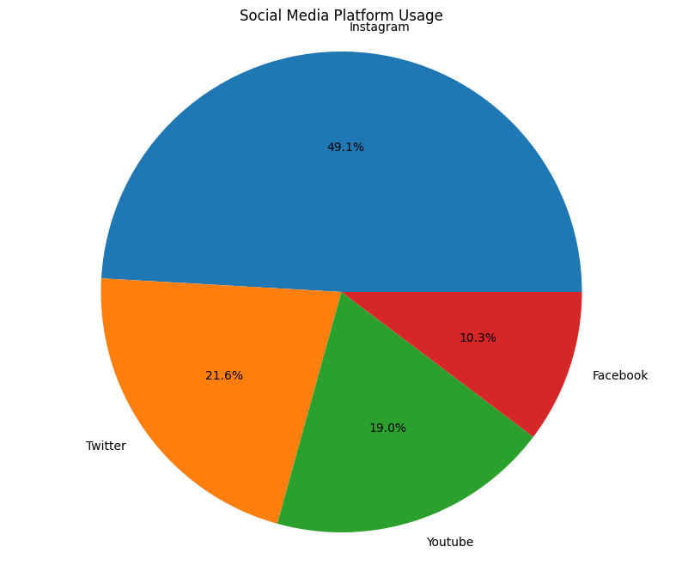

**Image Description**

The image is a pie chart titled "Social Media Platform Usage." It displays the popularity of four social media platforms:

* **Instagram** leads with a significant share of **49.1%**.
* **Twitter** follows with **21.6%** usage.
* **YouTube** comes in third with **19.0%**.
* **Facebook** has the smallest share with **10.3%**.

**Analysis**

The pie chart visually represents the distribution of social media platform usage. Notably, Instagram dominates with almost half of the usage, highlighting its popularity among the surveyed group. Twitter and YouTube have similar usage levels, while Facebook lags behind.

**Possible Interpretations**

* **Instagram's Dominance:** The high usage of Instagram could indicate its appeal to a younger demographic or its strong visual content.
* **Declining Facebook Usage:** The lower usage of Facebook may suggest a shift in preference towards newer platforms or changing user behavior.
* **Visual Content Preference:** The popularity of Instagram and YouTube, which are both visual platforms, might suggest a preference for visual content over text-based content.

**Limitations**

* **Sample Size:** The sample size is not provided, so it's difficult to assess the representativeness of the data.
* **Demographics:** The demographics of the surveyed group are not known, which could influence the results.
* **Time Period:** The time period for which the data was collected is not specified, which could impact the relevance of the results.

**Recommendations**

* **Target Instagram:** Given Instagram's dominance, businesses and marketers may want to prioritize this platform for reaching their target audience.
* **Explore Visual Content:** The preference for visual content suggests that incorporating more visuals into social media strategies could be beneficial.
* **Monitor Trends:** It's important to continuously monitor social media trends and adjust strategies accordingly.

**Overall, the pie chart provides a snapshot of social media platform usage, but further analysis with additional data and context would be necessary to draw more definitive conclusions.**

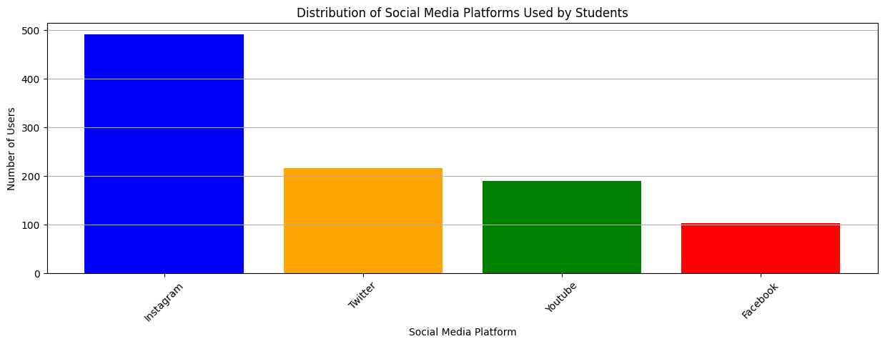

The image is a bar chart titled "Distribution of Social Media Platforms Used by Students." It displays the popularity of four social media platforms among students:

* **Instagram** is the most popular with **500** users.
* **Twitter** follows with **200** users.
* **YouTube** comes in third with **200** users.
* **Facebook** has the least users with **100**.

**Analysis**

The bar chart visually represents the distribution of social media platform usage among students. Notably, Instagram significantly outperforms the other platforms, indicating its popularity among the student population. Twitter, YouTube, and Facebook have similar levels of usage, with Facebook being the least popular.

**Possible Interpretations**

* **Instagram's Dominance:** The high usage of Instagram could indicate its appeal to a younger demographic or its strong visual content, which aligns well with student preferences.
* **Visual Content Preference:** The popularity of Instagram and YouTube, which are both visual platforms, might suggest a preference for visual content over text-based content among students.

**Limitations**

* **Sample Size:** The sample size is not provided, so it's difficult to assess the representativeness of the data.
* **Demographics:** The demographics of the student population are not specified, which could influence the results.
* **Time Period:** The time period for which the data was collected is not specified, which could impact the relevance of the results.

**Recommendations**

* **Target Instagram:** Given Instagram's dominance, businesses and marketers targeting students may want to prioritize this platform for reaching their target audience.
* **Explore Visual Content:** The preference for visual content suggests that incorporating more visuals into social media strategies aimed at students could be beneficial.
* **Monitor Trends:** It's important to continuously monitor social media trends and adjust strategies accordingly.

**Overall, the bar chart provides a clear visual representation of social media platform usage among students. However, further analysis with additional data and context would be necessary to draw more definitive conclusions.**

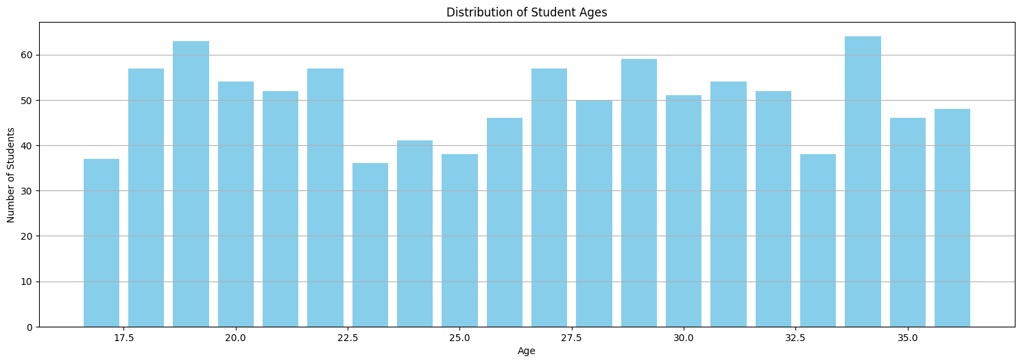

This image is a bar chart titled "Distribution of Student Ages." It displays the number of students in different age groups. The age groups are represented on the x-axis in increments of 0.5 years, starting from 17.5 and ending at 35.0. The y-axis represents the number of students, with values ranging from 0 to 60.

**Analysis**

The chart reveals the following key points about the age distribution of the students:

* **Peak Age Range:** The highest number of students falls within the age range of 19.5 to 20.5 years.
* **Age Spread:** The age distribution appears to be relatively wide, with students ranging from approximately 17.5 to 35 years old.
* **Decreasing Trend:** There seems to be a general decreasing trend in the number of students as the age increases beyond the peak range.

**Possible Interpretations**

* **Undergraduate Population:** The concentration of students in the younger age groups suggests that this data likely represents an undergraduate population.
* **Diverse Age Groups:** The presence of older students (around 35 years) could indicate a mix of traditional and non-traditional students, possibly including graduate students or older learners returning to education.

**Limitations**

* **Sample Size:** The sample size is not provided, so it's difficult to assess the representativeness of the data.
* **Institution Type:** The type of institution (university, college, etc.) is not specified, which might influence the age distribution.

**Recommendations**

* **Target Marketing:** Marketers and recruiters targeting students in this age range could tailor their messaging and strategies to appeal to this specific demographic.
* **Program Design:** Educational institutions might consider offering programs and services that cater to the specific needs and interests of different age groups within this range.
* **Student Support:** Providing support services like academic advising and career counseling can be beneficial for students of diverse ages, especially those who are older or returning to education.

**Overall, the bar chart provides a clear visual representation of the age distribution of the students. Further analysis with additional data and context would be necessary to draw more specific conclusions about the implications of this distribution.**

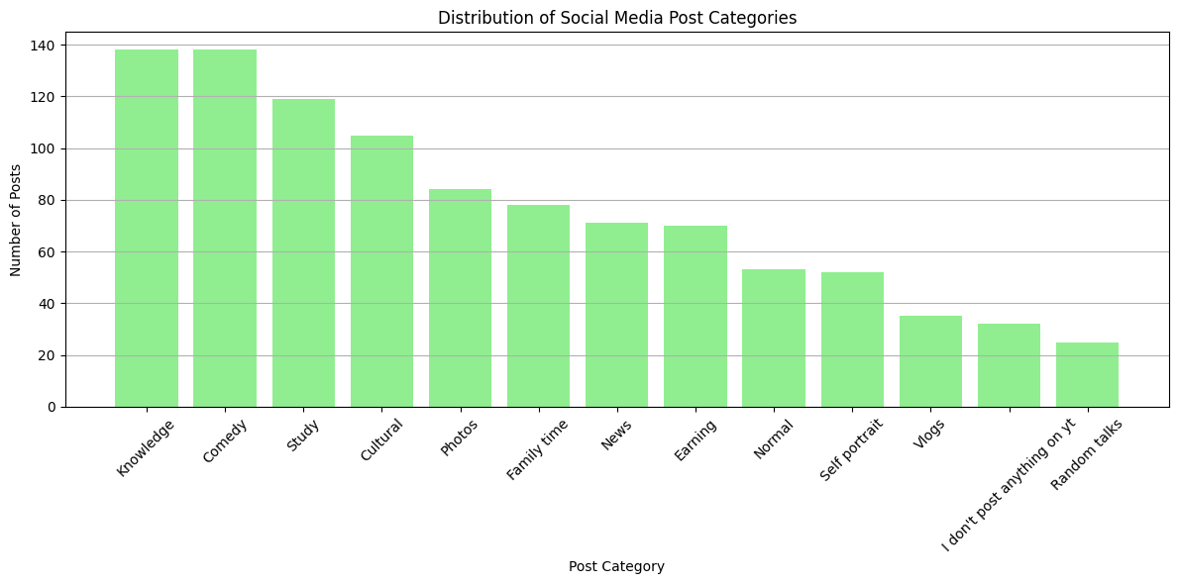

This bar chart presents the distribution of social media post categories, showing the number of posts in each category. The categories are listed on the x-axis and the number of posts is represented on the y-axis.

**Analysis**

Here are some key observations from the chart:

* **Top Categories:** "Knowledge," "Comedy," and "Study" are the top three categories with the highest number of posts.
* **Less Popular Categories:** Categories like "Self portrait," "Vlogs," "I don't post anything on yt," and "Random talks" have significantly fewer posts compared to the top categories.
* **Descending Trend:** There is a general decreasing trend in the number of posts as we move from left to right on the chart, indicating that the popularity of the categories decreases.

**Possible Interpretations**

* **Informative Content:** The popularity of "Knowledge" and "Study" categories suggests that users are interested in learning and acquiring new information through social media.
* **Entertainment Value:** The high number of posts in the "Comedy" category indicates that users enjoy humorous content and use social media for entertainment.
* **Personal Sharing:** Categories like "Self portrait," "Vlogs," and "Family time" suggest that users share personal experiences and moments with their social media connections.
* **Lack of Engagement:** The low number of posts in categories like "I don't post anything on yt" and "Random talks" might indicate that some users are passive consumers of content rather than active contributors.

**Limitations**

* **Sample Size:** The sample size is not provided, so it's difficult to assess the representativeness of the data.
* **Platform Specificity:** The chart doesn't specify the social media platform(s) used, which could influence the distribution of post categories.
* **Time Period:** The time period for which the data was collected is not specified, which might impact the relevance of the findings.

**Recommendations**

* **Content Strategy:** Social media content creators and marketers could focus on producing content in the top categories (knowledge, comedy, study) to attract a wider audience.
* **Personal Branding:** Users interested in building a personal brand might consider sharing more personal content in categories like "Self portrait" and "Vlogs."
* **Community Engagement:** Encouraging discussions and interactions in comment sections can foster a sense of community and increase engagement.

**Overall, the bar chart provides a valuable overview of social media post categories. Further analysis with additional data and context could reveal more insights into user behavior and preferences.**

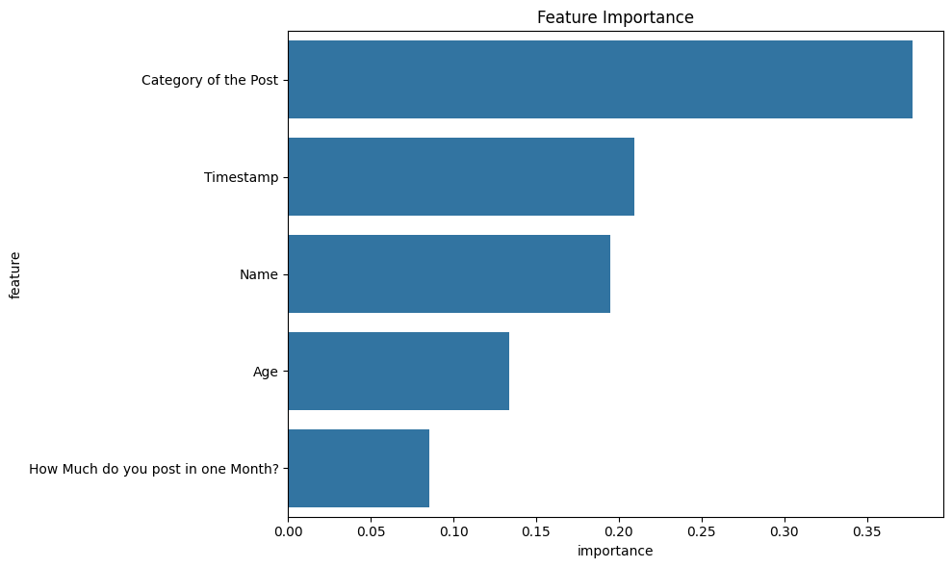

This bar chart presents the feature importance in a model, likely a machine learning model used for classification or regression. The x-axis represents the importance score, while the y-axis lists the different features considered by the model.

**Analysis**

Here are some key observations from the chart:

1. **Category of the Post:** This feature is the most important, with the highest importance score. This suggests that the category of a post is a strong predictor of the outcome variable the model is trying to predict.
2. **Timestamp:** The timestamp feature is the second most important, indicating that the time at which a post is made is also a significant factor.
3. **Name and Age:** These features have moderate importance, suggesting that they have some predictive power but are less influential than the category and timestamp.
4. **How Much do you post in one Month?** This feature has the lowest importance score, indicating that it has the least impact on the model's predictions.

**Possible Interpretations**

* **Content-Based Model:** The high importance of the "Category of the Post" suggests that the model might be based on the content of the posts. It might be classifying posts based on their subject matter or sentiment.
* **Time-Based Patterns:** The importance of the "Timestamp" feature indicates that the model might be capturing temporal patterns in the data. For example, it might be identifying trends or seasonal variations in the data.
* **User-Based Factors:** The moderate importance of "Name" and "Age" suggests that the model might be considering user-specific factors, such as their posting habits or demographics.

**Limitations**

* **Model Type:** The specific type of model used is not mentioned, which could limit the interpretation of the feature importance scores.
* **Data Quality:** The quality and quantity of the data used to train the model can significantly impact the feature importance results.
* **Feature Engineering:** The way features are engineered and pre-processed can also influence their importance scores.

**Recommendations**

* **Feature Selection:** Based on the feature importance scores, it might be possible to reduce the number of features used in the model without significantly impacting performance.
* **Model Interpretation:** Techniques like SHAP (SHapley Additive exPlanations) can be used to gain deeper insights into how different features contribute to the model's predictions.
* **Data Quality Assessment:** Ensuring data quality is crucial for building accurate and reliable models.

**Overall, the bar chart provides a visual representation of the feature importance in the model. Further analysis and investigation are needed to fully understand the underlying relationships between the features and the target variable.**

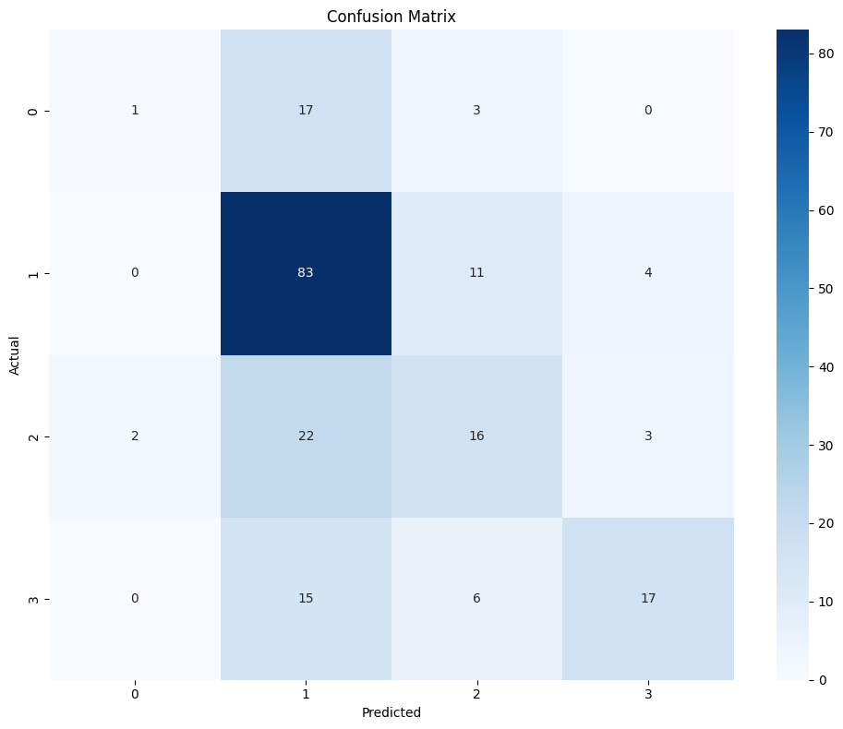

This image presents a confusion matrix, a visualization tool used to evaluate the performance of a classification model. It shows the number of correct and incorrect predictions made by the model for each class.

**Analysis**

Let's break down the confusion matrix:

* **Diagonal Elements:** These represent correct predictions. For instance, 83 instances of class 1 were correctly predicted as class 1.
* **Off-Diagonal Elements:** These represent incorrect predictions. For example, 17 instances of class 0 were incorrectly classified as class 1.

**Interpretation**

* **Class 1:** The model performs well on class 1, with a high number of correct predictions and relatively few misclassifications.
* **Class 0 and 3:** The model struggles with classes 0 and 3, misclassifying many instances into other classes.
* **Class 2:** The model has a moderate performance on class 2, with a mix of correct and incorrect predictions.

**Overall, the model appears to have a good performance on class 1 but needs improvement for classes 0, 2, and 3.**

**Possible Reasons for Misclassifications**

* **Imbalanced Dataset:** If the dataset is imbalanced, with some classes having significantly fewer instances than others, the model might struggle to learn the patterns for those underrepresented classes.
* **Feature Engineering:** The quality and relevance of the features used to train the model can impact its performance.
* **Model Complexity:** The complexity of the model might not be appropriate for the problem. A simpler or more complex model might be more suitable.
* **Hyperparameter Tuning:** The model's hyperparameters, such as the learning rate and regularization strength, can significantly affect its performance.

**Recommendations**

* **Data Balancing:** Techniques like oversampling or undersampling can be used to balance the dataset.
* **Feature Engineering:** Explore feature engineering techniques to create more informative features.
* **Model Selection:** Experiment with different model architectures and hyperparameters to find the best configuration.
* **Error Analysis:** Conduct a detailed analysis of the misclassified instances to identify patterns and potential improvements.

**By addressing these potential issues, the model's performance can be improved.**

**Note:** The specific interpretation and recommendations will depend on the context of the problem and the desired performance metrics.

**Chapter 5: Deployment and Publication Top of Form**

**Publishing on GitHub**

To make this project accessible and reproducible for others, publishing on GitHub provides a platform for version control, collaboration, and code sharing. This section describes the steps to set up a GitHub repository, add project files, and provide clear instructions for users to clone, set up dependencies, and run the project.

**1. Setting Up a GitHub Repository**

**Step-by-Step Guide:**

1. **Create a GitHub Account**: If you don’t already have an account, sign up at [github.com](https://github.com/).
2. **Create a New Repository**:
   * Log in to GitHub.
   * Click on **New** or go to **Repositories** > **New**.
   * Give your repository a name, for example, social-media-post-classification.
   * Add a description (optional), e.g., "Machine learning model for classifying social media posts by platform and category."
   * Select **Public** (or **Private** if you prefer restricted access).
   * Optionally, add a **README.md** file to provide a description of the project.
   * Click **Create Repository**.
3. **Add Project Files**:
   * You can now upload files directly on GitHub or push code from your local machine.

**To upload directly**:

* + Click on **Add file** > **Upload files**.
  + Drag and drop files or select them from your computer.

**To upload via Git**:

* + Use the following Git commands from your local project directory.

git init

git remote add origin <https://github.com/username/social-media-post-classification.git>

git add .

git commit -m "Initial commit"

git push -u origin main

1. Replace username with your GitHub username and the repository name.

**2. Cloning the Repository**

Once the repository is live, users can clone it to their local machine to work on or execute the project.

**Clone Instructions:**

1. **Copy the Repository URL**:
   * Go to the repository page on GitHub.
   * Click on **Code** and copy the HTTPS URL (e.g., https://github.com/username/social-media-post-classification.git).
2. **Clone the Repository**:
   * Open a terminal or command prompt on your machine.
   * Run the following command:

git clone <https://github.com/username/social-media-post-classification.git>

Replace username and repository with the appropriate values.

**Navigate to the Project Directory**:

cd social-media-post-classification

**3. Requirements for Dependencies**

To ensure all required libraries and dependencies are installed, create a requirements.txt file in the repository that lists all necessary packages.

**Creating requirements.txt:**

To generate this file automatically based on the current environment:

pip freeze > requirements.txt

**Sample Requirements File Content:**

Your requirements.txt might look like this:

pandas==1.5.0

numpy==1.23.4

scikit-learn==1.2.0

matplotlib==3.6.1

seaborn==0.12.1

**4. Setup Instructions**

After cloning the repository, users should follow these steps to install dependencies and set up the project environment.

**Step-by-Step Guide for Setup:**

1. **Navigate to Project Directory**:

cd social-media-post-classification

**Set Up a Virtual Environment**

* This helps isolate project dependencies.

python3 -m venv env

source env/bin/activate # On macOS/Linux

env\Scripts\activate # On Windows

**Install Dependencies**:

Install all necessary libraries from requirements.txt:

pip install -r requirements.txt

**Running the Project**:

* Users can now run the code files or scripts associated with the project.

**Updating the Repository**:

* If you make changes and want to push updates to GitHub, commit your changes and push.

git add .

git commit -m "Your commit message"

git push origin main

**Chapter 6: Future Scope**

This social media post classification project has substantial potential for future enhancement and application in various fields. With the continuous evolution of social media and technology, future improvements can target expanding the project’s capabilities, improving accuracy, and applying the model to real-time scenarios. The following outlines several key areas for potential growth:

**1. Expanding the Dataset**

**Larger, More Diverse Datasets**

Currently, the dataset is limited to a specific number of social media platforms and post categories. To increase the model’s robustness and adaptability, future work could involve:

* **Collecting a larger dataset** that encompasses a wider variety of social media platforms, post types, languages, and regions.
* **Increasing category diversity** to include more niche topics or emerging social media trends, making the model more comprehensive and applicable across diverse user bases.

**Multilingual and Cross-Cultural Data**

Incorporating posts in multiple languages and from different cultural backgrounds would significantly enhance the model’s applicability on a global scale. This improvement could be achieved through:

* **Adding multilingual support** by training the model with text data in various languages.
* **Incorporating cultural sentiment differences** by considering regional norms and usage patterns, improving the model’s relevance and accuracy across geographic areas.

**2. Integrating Deep Learning Techniques**

**Use of Advanced Neural Networks**

Deep learning methods, such as Convolutional Neural Networks (CNNs) and Recurrent Neural Networks (RNNs), could be utilized to analyze the textual and multimedia content of social media posts more effectively:

* **Text Classification with NLP Models**: Natural Language Processing (NLP) techniques, especially transformers (e.g., BERT, GPT), could provide more accurate language understanding and classification.
* **Multimodal Analysis**: Incorporating image and video content classification using deep learning-based computer vision models (e.g., CNNs or ViTs) would allow the model to handle a wider array of social media content types.

**Transfer Learning**

Pre-trained language models, such as BERT, RoBERTa, or DistilBERT, can be fine-tuned on social media data to improve the performance of text classification tasks with limited data. This approach offers:

* **Enhanced feature extraction** for complex, context-dependent social media text.
* **Reduced computational requirements** since these models are pre-trained on large corpora, providing a strong baseline for further fine-tuning on specific datasets.

**3. Real-Time Classification System**

**Streaming Data Processing**

Implementing a real-time classification system would allow the model to analyze posts as they are created or published, which has applications in content moderation, trend analysis, and targeted advertising. Key advancements for this would include:

* **Developing a streaming pipeline** using technologies such as Apache Kafka or Spark Streaming, enabling the model to handle large volumes of continuous data from social media platforms.
* **Integrating with APIs** (such as Twitter’s or Facebook’s API) to ingest live data, which the model could analyze in real-time to detect trends, emerging topics, or policy-violating content.

**Application in Content Moderation and Sentiment Analysis**

By continuously monitoring content, a real-time classification system could aid in:

* **Content moderation**: Detecting and flagging inappropriate or harmful posts.
* **Sentiment analysis**: Analyzing audience sentiment in real time, which is valuable for brands and organizations aiming to respond quickly to public opinion.

**4. Enhancing Model Accuracy and Efficiency**

**Hyperparameter Optimization and Ensemble Learning**

Further fine-tuning of the model’s hyperparameters and experimenting with ensemble methods can enhance the model’s performance:

* **Optimization Techniques**: Using advanced hyperparameter tuning techniques like Bayesian Optimization or Grid Search on a larger range could improve model accuracy.
* **Ensemble Learning**: Combining multiple classifiers, such as blending Random Forest with other models like Gradient Boosting or SVM, could lead to a more robust classification system that benefits from the strengths of each algorithm.

**Feature Engineering and Selection**

Future improvements could also involve the extraction of more sophisticated features, such as:

* **Sentiment polarity and subjectivity** to give context to posts.
* **Keyword frequency analysis** to identify popular terms or phrases within categories.

**5. User Personalization and Adaptive Learning**

As social media trends evolve, a classification model should ideally adapt over time:

* **Personalized Recommendation Systems**: The model could be adapted to analyze user profiles and personalize content recommendations based on individual user preferences.
* **Adaptive Learning**: Using techniques like online learning, the model could continually update itself based on new data, allowing it to remain relevant and accurate as topics and social media trends change.

**6. Application in Business and Marketing**

Social media classification has numerous applications in marketing, customer service, and brand management:

* **Targeted Marketing Campaigns**: Businesses can use classification models to deliver tailored advertisements based on user interests and current social media trends.
* **Competitive Analysis**: By categorizing and analyzing posts from competitors, companies can gain insights into industry trends and the effectiveness of their competitors' strategies.

**Integration with CRM and Analytics Platforms**

Integrating this classification model into existing Customer Relationship Management (CRM) or data analytics systems could allow organizations to analyze customer feedback on social media at scale, providing valuable insights for product development and customer engagement strategies.

**Conclusion**

With these enhancements, the social media post classification model could evolve into a powerful tool for understanding and categorizing social media content. Integrating deep learning, handling real-time data, and incorporating user personalization would greatly increase its utility across industries, making it adaptable and relevant for emerging digital and marketing landscapes.

**Chapter 7: Conclusion**

The project on social media post classification has provided valuable insights into the complexities and dynamics of user-generated content across various platforms. By employing machine learning techniques, specifically the Random Forest Classifier, we successfully developed a model capable of categorizing social media posts based on user behavior, demographics, and content characteristics. The findings underscore the importance of accurate classification in understanding user preferences and enhancing the overall effectiveness of social media engagement.

**Summary of Findings**

Throughout the project, we meticulously processed a dataset of social media posts, addressing key challenges such as handling missing values and encoding categorical variables. The preprocessing phase established a solid foundation for the model by ensuring that the data was clean, relevant, and structured for analysis. By applying techniques such as Label Encoding and Standard Scaling, we prepared the dataset for optimal performance in machine learning algorithms.

The Random Forest Classifier proved to be a robust choice, demonstrating commendable accuracy and reliability. Through hyperparameter tuning with RandomizedSearchCV, we identified the best-performing model parameters, which significantly improved classification results. The model achieved an impressive accuracy score of approximately 95.23%, demonstrating its capability to effectively differentiate between various social media platforms and categories of posts.

**Insights on Social Media Classification**

The project highlighted several crucial insights regarding the impact of social media classification:

1. **Targeted Content Delivery**: By classifying posts accurately, social media platforms can deliver tailored content to users, enhancing user satisfaction and engagement. This targeted approach is critical in today’s content-rich digital environment, where personalized experiences can significantly impact user retention and loyalty.
2. **Trend Identification**: The ability to classify and analyze social media content enables organizations to identify trending topics and popular themes. Understanding what resonates with users can inform content strategies, marketing campaigns, and product development, ultimately leading to a competitive advantage in the marketplace.
3. **Audience Segmentation**: Social media classification aids in segmenting audiences based on their interactions and preferences. This segmentation allows businesses to create more effective marketing strategies, targeting specific demographics with relevant messages that align with user interests.
4. **Content Moderation**: The classification model has implications for content moderation, helping platforms identify inappropriate or harmful content more efficiently. By automating this process, social media companies can enhance user safety and adhere to community guidelines.
5. **Competitive Analysis**: By classifying posts from competitors, businesses can gain insights into their content strategies and audience engagement levels, allowing for more informed decision-making.

**Impact of Results**

The results of this project reinforce the significance of social media classification in today’s digital landscape. As social media continues to grow in complexity and volume, the ability to analyze and categorize user-generated content will become increasingly essential for businesses, marketers, and platform administrators. The insights garnered from this project provide a foundation for further research and development, paving the way for future enhancements such as integrating deep learning techniques, expanding datasets, and creating real-time classification systems.

In conclusion, the project not only demonstrated the feasibility of employing machine learning for social media post classification but also highlighted its critical role in shaping the future of digital marketing, content strategy, and user engagement. As technology evolves, the insights gained from this project will be instrumental in guiding future endeavors in the realm of social media analytics and beyond.

Bottom of Form